Topics: Confidence Intervals

- For each of the following statements, indicate whether it is True/False. If false, explain why.

- The sample size of the survey should at least be a fixed percentage of the population size in order to produce representative results
Ans… False - The results depend on the size(n) of the sample. The sample size should have at least 30 observations.

- The sampling frame is a list of every item that appears in a survey sample, including those that did not respond to questions.
Ans…False - The sampling frame should contain only those items that have responded because the items with no response adds no value the analysis and just increases the size of data.

- Larger surveys convey a more accurate impression of the population than smaller surveys.
Ans…True- More the size of sample, it captures maximum patterns thats helps to build an accurate model.

- PC Magazine asked all of its readers to participate in a survey of their satisfaction with different brands of electronics. In the 2004 survey, which was included in an issue of the magazine that year, more than 9000 readers rated the products on a scale from 1 to 10. The magazine reported that the average rating assigned by 225 readers to a Kodak compact digital camera was 7.5. For this product, identify the following:

- The population - Readers of the magazine =9000
- The parameter of interest- Rating of the camera(7.5)
- The sampling frame - All readers of the issue where the survey was included.
- The sample size - 225 readers
- The sampling design - Voluntary Response
- Any potential sources of bias or other problems with the survey or sample
- Selection of the readers, selection of the issue which will contain the survey

- For each of the following statements, indicate whether it is True/False. If false, explain why.

- If the 95% confidence interval for the average purchase of customers at a department store is $50 to $110, then $100 is a plausible value for the population mean at this level of confidence.
Ans. True - Confidence interval identifies the collection of values for the population parameter that are consistent with the observed sample.
- If the 95% confidence interval for the number of moviegoers who purchase concessions is 30% to 45%, this means that fewer than half of all moviegoers purchase concessions.
Ans.False- The above information implies only for 30 to 45% of moviegoers at 95 % confidence further than this we do not have any knowledge. Therefore, we cannot be 100% sure for the above statement

- The 95% Confidence-Interval for μ only applies if the sample data are nearly normally distributed.
Ans. False: The 95% confidence Interval for population mean can be applied to distribution that aren’t normal, but they are easy to understand in symmetric distributions.
We can use the central limit theorem to make a normal approximation. The rule where about 95% of observations are within 2 standard deviations of the mean is only approximately true. However, it holds very well for the normal distribution. The mean of data tends to be normally distributed when the sample size is sufficiently large.

- What are the chances that ?

- ¼
- ½
- ¾
- 1
Ans. : B (This is only an assumption, because if we consider more than 50% for sample mean to be greater than the probability of getting a lower value gets overshadowed because sample mean has an equal chance to be lesser than population mean.)

- In January 2005, a company that monitors Internet traffic (WebSideStory) reported that its sampling revealed that the Mozilla Firefox browser launched in 2004 had grabbed a 4.6% share of the market.

- If the sample were based on 2,000 users, could Microsoft conclude that Mozilla has a less than 5% share of the market?
Ans. No
As the p Value > alpha for 95% confidence we failed to reject null hypothesis
Ho: > 5% null hypothesis
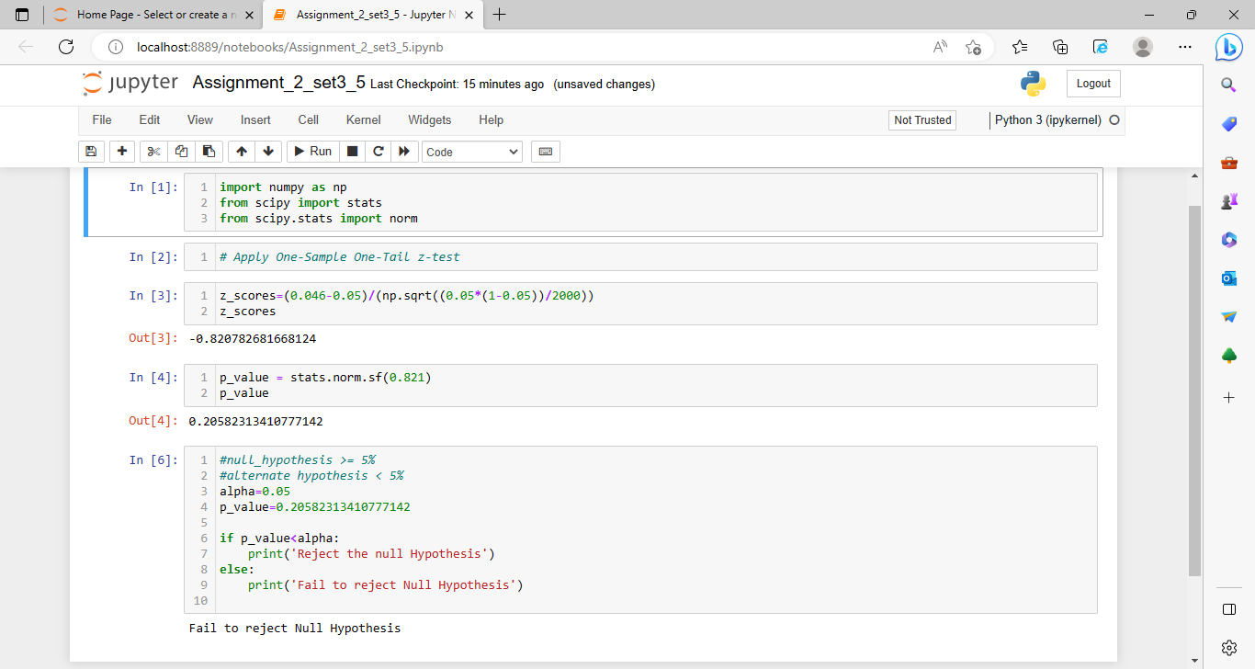

- WebSideStory claims that its sample includes all the daily Internet users. If that’s the case, then can Microsoft conclude that Mozilla has a less than 5% share of the market?
Ans. Yes- In this case, we have data on the entire population and the sample value accurately reflects the population number. Thus we can conclude that the share is less than 5%.

- A book publisher monitors the size of shipments of its textbooks to university bookstores. For a sample of texts used at various schools, the 95% confidence interval for the size of the shipment was 250 ± 45 books. Which, if any, of the following interpretations of this interval are correct?

- All shipments are between 205 and 295 books.
Ans. Incorrect 95% of the time the size of the shipment will be around 250 +/- 45 books

- 95% of shipments are between 205 and 295 books.
Ans. Incorrect. The interval doesn’t describe individual shipments.

- The procedure that produced this interval generates ranges that hold the population mean for 95% of samples.
Ans. Correct. 95% of intervals created in this way contain the true population mean.

- If we get another sample, then we can be 95% sure that the mean of this second sample is between 205 and 295.
Ans. Incorrect. The interval doesn’t describe the mean of another sample.

- We can be 95% confident that the range 160 to 340 holds the population mean.
Ans. Incorrect: as we increase the range +/- 1 sigma the % of confidence increases for a normal distribution it will be 97.5% that the mean will lie in between 160 to 340 (-3 sigma to +3 sigma)

- Which is shorter: a 95% z-interval or a 95% t-interval for μ if we know that σ =s?

- The z-interval is shorter
- The t-interval is shorter
- Both are equal
- We cannot say
Ans: A
When the population standard deviation (σ) is unknown and is estimated using the sample standard deviation (s), the confidence interval for the population mean (μ) is calculated using the t-distribution. The t-distribution has heavier tails compared to the standard normal (z) distribution, which is used when the population standard deviation is known.
Because of the heavier tails of the t-distribution, the confidence interval calculated using the t-distribution will be wider than the confidence interval calculated using the z-distribution for the same level of confidence (such as 95%). Therefore, the t-interval will be longer than the z-interval when the population standard deviation is estimated from the sample.

Questions 8 and 9 are based on the following: To prepare a report on the economy, analysts need to estimate the percentage of businesses that plan to hire additional employees in the next 60 days.
Ans. A: For 95% confident Z-interval is shorter (1.960), as for t-interval (1.962) it increases as degree of freedom decreases.
- How many randomly selected employers (minimum number) must we contact in order to guarantee a margin of error of no more than 4% (at 95% confidence)?

- 600
- 400
- 550
- 1000
Ans. A
Margin of Error = Z * under root (p hat *q hat/ n) n = sample size, Z is score depends on the confidence level, p hat is the predictable value and q hat is the value to be predicted value
let’s assume p hat and q hat as 0.5 and margin of error is given 0.04
n = (z)^2 * p hat * q hat / ME^2
n = (1.96) ^2 * (0.5) (0.5) / (0.04) ^2
n = 600 sample size

- Suppose we want the above margin of error to be based on a 98% confidence level. What sample size (minimum) must we now use?

- 1000
- 757
- 848
- 543
Ans. C
Let’s assume p hat and q hat as 0.5 and margin of error is given 0.04
n = (z)^2 * p hat * q hat / ME ^2
n = (2.326) ^2 * (0.5) (0.5) / (0.04) ^2
n = 845 samples size

